Task1

class address{  
 String street**,**city**,**state**,**zipCode**;** public boolean check(String zipCode){  
 int c=Integer.*parseInt*(zipCode)**;** if (c>**10000**&&c<**99999**){  
 System.*out*.println("Valid")**;** return true**;** }  
 else {System.*out*.println("Invalid")**;** return false**;**}  
 }  
}  
class employee{  
 address a1 = new address()**;** String firstName**,**lastName**;** public void print(){  
 System.*out*.println("First Name "+firstName+ " Last Name"+lastName+" Address "+a1.street+" "+a1.city+" "+a1.state+" "+a1.zipCode)**;** }  
}  
public class Main {  
 public static void main(String[] args) {  
  
 employee e1 = new employee()**;** e1.firstName="Partham"**;** e1.lastName="Kumar"**;** e1.a1.street="420"**;** e1.a1.state="Sindh"**;** e1.a1.city="Hyderabad"**;** e1.a1.zipCode="45859"**;** e1.print()**;** e1.a1.check(e1.a1.zipCode="45859")**;** }  
}

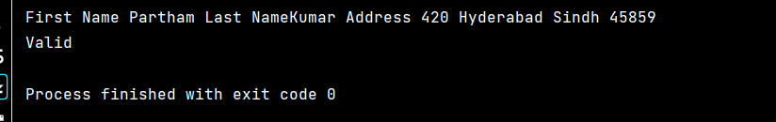

Task 2

class house{  
 //Inner Class  
 public class room{  
 private String type**,**size**;** private double temp**;** public void setType(String type) {  
 this.type = type**;** }  
  
 public void setSize(String size) {  
 this.size = size**;** }  
  
 public void setTemp(double temp) {  
 this.temp = temp**;** }  
  
 public String getType() {  
 return type**;** }  
  
 public String getSize() {  
 return size**;** }  
  
 public double getTemp() {  
 return temp**;** }  
 public void display(){  
 System.*out*.println("Type is "+type)**;** System.*out*.println("Size is "+size)**;** System.*out*.println("Temp is "+temp)**;** }  
 }  
}  
public class Main {  
 public static void main(String[] args) {  
 System.*out*.println("Hello world!")**;** // Creating object of outer class  
 house house=new house()**;** //creating object of inner class  
 house.room obj = house.new room()**;** obj.setTemp(**26.50**)**;** obj.setSize("20*25")**;** obj.setType("Classic")**;** obj.display()**;** }  
}

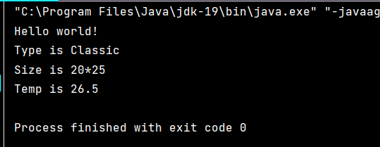

Task 3

import java.util.ArrayList**;**import java.util.Collections**;**class shopingCarts{  
 ArrayList<String> itemList =new ArrayList<String>()**;** public void addItem(String item){  
 itemList.add(item)**;** }  
 public void print(){  
 class itemSorter{  
 shopingCarts st = new shopingCarts()**;** }  
 Collections.*sort*(itemList)**;** System.*out*.println(itemList)**;** }  
}  
public class Main {  
 public static void main(String[] args) {  
 System.*out*.println("22k-4079")**;** shopingCarts s1 = new shopingCarts()**;** s1.addItem("Mouse")**;** s1.addItem("Keyboard")**;** s1.addItem("Sensor")**;** s1.addItem("Scanner")**;** s1.addItem("Charger")**;** s1.print()**;** }  
}

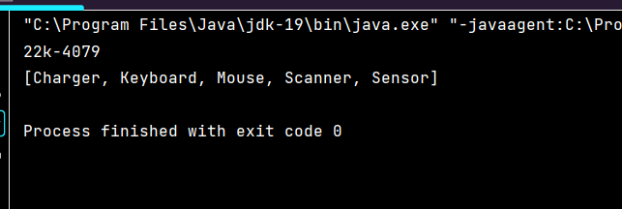

Task 4

class vehicle{  
 String model**,**name**,**engine**,**cc**;** public void display(){  
 System.*out*.println(model)**;** System.*out*.println(name)**;** System.*out*.println(engine)**;** System.*out*.println(cc)**;** class owner{  
 private String cnic**,**phno**;** public void setCnic(String cnic) {  
 this.cnic = cnic**;** }  
  
 public void setPhno(String phno) {  
 this.phno = phno**;** }  
  
 public String getCnic() {  
 return cnic**;** }  
  
 public String getPhno() {  
 return phno**;** }  
 }  
 }  
  
}  
public class Main {  
 public static void main(String[] args) {  
 vehicle v1 = new vehicle()**;** v1.name="Alto"**;** v1.engine="EFI"**;** v1.cc="660"**;** v1.model="2003"**;** v1.display()**;** }  
}

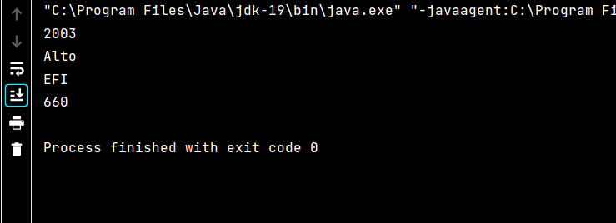

Task 5 class Car {  
 private String carName**;** private String carType**;** public Car(String Name**,** String Type) {  
 carName = Name**;** carType = Type**;** }  
  
 private String getCarName() {  
 return carName**;** }  
  
 public Engine createEngine() {  
 return new Engine()**;** }  
  
 public class Engine {  
 private String engType**;** public Engine() {  
 if (carType.equals("4T")) {  
 if (carName.equals("Mehran")) {  
 engType = "Small"**;** } else {  
 engType = "Large"**;** }  
 } else {  
 engType = "Bigger"**;** }  
 }  
  
 public String getEngtype() {  
 return engType**;**}  
}  
}  
public class Main {  
 public static void main(String[] args) {  
 Car mycar = new Car("Mehran"**,** "4T")**;** Car.Engine myengine = mycar.createEngine()**;** System.*out*.println("My car's engine type is " + myengine.getEngtype())**;** Car yourcar = new Car("ALTO"**,** "3T")**;** Car.Engine yourengine = yourcar.createEngine()**;** System.*out*.println("Your car's engine type is " + yourengine.getEngtype())**;**}  
  
  
}

